Contribution title
Subtitle
First Author1[https://orcid.org/0000-1111-2222-3333], Second Author 2[https://orcid.org/1111-2222-3333-4444], and Third Author 3[https://orcid.org/1111-2222-3333-5555]
¹ University College London, UK
² TIB Open Publishing, Germany
³ Technische Hochschule Wildau, Germany
Abstract. The abstract should summarize the contents of the paper in short terms, i.e. in up to 250 words.
Keywords: First keyword, second, third keyword

First section

Subsection
Please notice that there is no indent in the first paragraph of a section or subsection. There also no indent in the first paragraphs which follow a table, figure, equation, etc.
Nevertheless, following paragraphs are indented.

Three levels of headlines may be used
Please only use the formatting styles predefined in this file. Use the “Standard” formatting for the text.
Table 1. Table captions should be placed above the tables.
Hazard Class | A 1 to A III
Flash point | < 21 °C / > 55 °C
Density at 15 °C | 720 kg/m3 to 860 kg/m3
Kinematic Viscosity | 0,65 to 4,0 x 10–6 m2/s
Tables and Figures should be centered.
- Bullet points may be used
- …
- Numbering may be used, too.
- …
Equations should be centred and set on a separate line.
x + y = z (1)
Whenever possible, use vector graphics and try to avoid rasterized images.
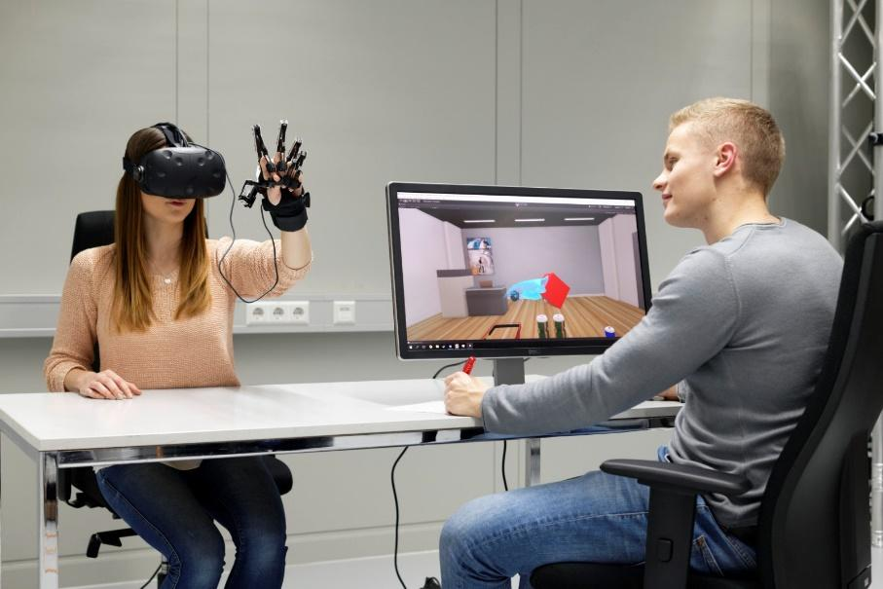
Figure 1. A figure caption is always placed below the illustration.
For citations of references, we prefer the use of square brackets and consecutive numbers, e.g. as shown by Author et al. [2], [3, pp. 5–10], as mentioned earlier [1], [3], [9]. The following bibliography provides the basic formats as a reference list with entries for journal articles [1], book chapter [2], as well as a URL [5]. For further guidance please refer to https://ieeeauthorcenter.ieee.org/wp-content/uploads/IEEE-Reference-Guide.pdf

References
- J. K. Author, “Name of paper,” Abbrev. Title of Journal , vol.x, no.x, pp. xxx–xxx, Abbrev. month, year, doi: https.doi.org/……
- J. K. Author, “Title of chapter in the book,” in Title of Their Published Book, xth ed. City of Publisher, (only U.S. State), Country: Abbrev. of Publisher, year, ch. x, sec. x, pp. xxx–xxx.
- First Name Initial(s) Last Name. “Page Title.” Website Title. Web Address (retrieved Date Accessed)

